Working heading: Government’s bulk billing incentives unlikely to succeed, GPs say
Bulk billing incentive likely to fail
Government’s bold bulk billing promise doomed
Bulk billing incentives won’t sway most GPS
Bulk billing incentives won’t win over most GPS
Working kicker: While bulk billing clinics are upbeat, mixed billing practices see little benefit…
With the launch date for new and expanded bulk billing incentives inching closer, the Government is sticking with its story that the bulk billing rate will rise to 90% by 2030…
But word at the coal face is that it’s looking highly unlikely.
From 1 November, the tripled bulk billing incentive will be available to all patients with a Medicare card, and practices that universally bulk bill will be eligible for a 12.5% Practice Incentive Program payment to be split evenly between GPs and practices.
“We looked at every single general practice in the country. We have access to every dollar they bill, whether it's billing Medicare or charging a gap fee to a patient,” Health Minister Mark Butler told the Conversation’s Michelle Grattan last week.
“We know that the funding we put on the table would mean that three quarters of practices are better off if they move to 100% bulk billing. The other quarter might not, but they’ll still be majority bulk billing. Most of them will still bulk bill pensioners and kids and so on. That’s how we got to our 90% figure,” he said.
Yet 49% of GPs say they are not at all likely to switch to universal bulk billing, and 20% say they’re only slightly likely, according to a national Healthed poll of over 1400 GPs last month.
While over 70% of polled GPs expect at least some improvement to the national bulk billing rate once the incentives take effect, they are less convinced it will make a significant difference to their practice’s financial viability or personal income.
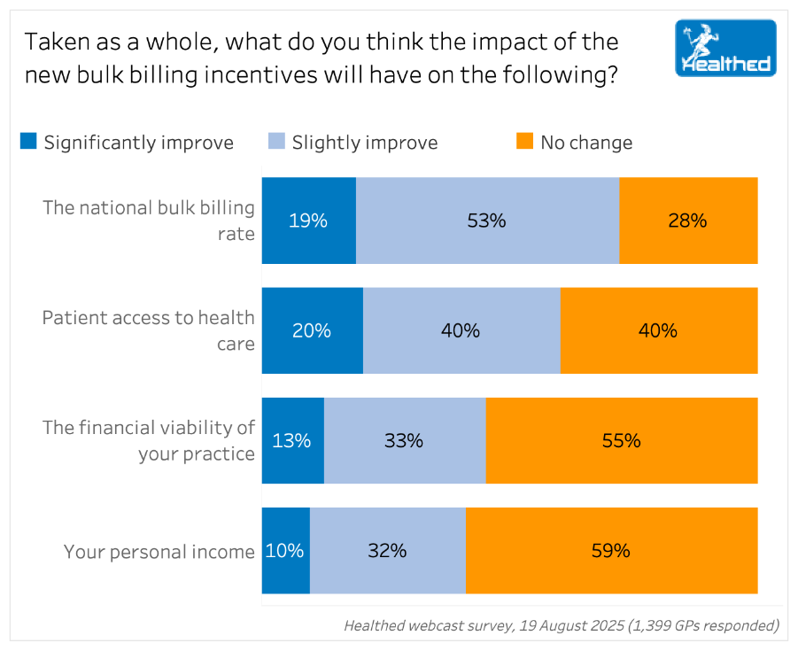
250819 Q26 Bulk billing policy impacts.png
Current billing type predicts attitudes toward the policy
GPs from mixed billing practices made up 69% of survey respondents and only 8% of that group think the new policies will significantly improve the financial viability of their practices, while 31% expect a slight improvement.
In terms of personal income, 28% of mixed billing GPs expect a slight improvement and 7% expect a significant improvement once the incentives come into force, while X percent expect no change.
The survey did not ask if GPs expected things to get worse, but several commented that universal bulk billing would significantly reduce their income, particularly those offering longer or more complex consultations—with the new incentives not seen as enough to offset the loss from private billing.
Unsurprisingly, GPs in bulk billing practices are much more positive about the impact of the new incentives. Around one quarter to one third believe the policy will significantly improve the national bulk billing rate, patient access to health care, the financial viability of their practice and their personal income.
Those at private billing practices were most pessimistic, with less than 10% saying it will significantly improve these factors, Healthed’s survey found.
GP, researcher and past president of the RACGP Professor Karen Price says the data shows “very clearly that the government’s claims are likely to fail.”
“And the sentiment of the GPs that I hear around the traps is that we are not going back....
We are not going back to a government that we don't trust, in terms of being able to provide and do our job. We want to do our job, and the way we do that is by, in most cases, mixed billing. So I don't think that they're certainly not going to get practices in middle-class areas or wealthy areas, switching over to full bulk billing, because that will be a pay cut.
And most doctors are working that out. And even if they get a temporary uplift, they figure that the government won't keep to their word, and that in two years' time there'll be more / less erosion of inflation, because healthcare inflation sits above CPI inflation, that those benefits will be eroded and we're back under the sum again. So this is a really challenging time, because the GPs have lost trust in the government to do the right thing.
I think the doctors have worked out that when they've looked at the way, the formula they've used, which is a really intensive general practice, multiple appointments over five days, and they've really maxed out that formula, which is not how people work.
when we say you're a mixed billing practice, obviously fully private are not going to do it. Obviously, all bulk billing practices will probably continue on that path, and they're a small percentage.
But the large majority of mixed billing practices will depend upon what percentage you are already providing subsidised care to. That's what it is. I
Doctors are very committed to providing quality care, and to do anything less for quality care is a reason for them to reconsider their career choices, either at the beginning, middle, or end of their careers.
“the government is prioritising access and forgetting about quality and GPs will not let go of quality,” she says
Medicare insurance is a contract between the government and the patient, it has nothing to do with doctors. So, if there's inadequate insurance from the government to meet the cost of quality care, that's firmly on the government.

When pressed, even Minister Butler admitted that market dynamics could pose challenges.
“We don't operate a health system like the British do, for example, where there's a very direct lever between the Government and what happens in healthcare settings like general practices. These are all private businesses,” he said.

GP, researcher and past president of the RACGP Professor Karen Price
it is greedy doctors wanting to make bags of money, why is there such a workforce crisis? Because people are not choosing general practice. And I long said, and I said it as President, that the workforce stats are a better proxy for the health of the healthcare system, particularly in the community. So, doctors want to provide good quality care, and when they can't, they get burned out and they leave the profession.
“They're certainly not going to get practices in middle-class or wealthy areas switching over to full bulk billing, because that will be a pay cut. And even if practices get a temporary uplift, they figure the government won't keep to their word,” she says.
Mixed billing makes GP viable for many
The incentives are another sign the government “is prioritising access and forgetting about quality,” Professor Price says. “And GPs will not let go of quality.”

To provide that quality, many practices use a mixed billing model, she points out.

“You may provide a service for someone who's very unfortunate, and discount that service heavily, but the next 10 patients pay privately. You're able to manage the business costs of your nurses, your IT, or your practice infrastructure by doing that kind of at-the-ground cross-subsidisation. That's always been the case.”
Maths will prove the matter
GP and health industry consultant Dr Joe Kosterich three quarters are either not likely or only slightly likely to change is pretty consistent with anecdotal discussions
ut you know, probably in excess of 85 to 90% of patients, then, you know, it's probable that you'll be slightly better off. If you've been bulk billing, that that percentage is 90%.
I really want to emphasize that it's very dependent on the individual numbers of the individual doctors, which is why these across the board of statements from Butler just reflect that he's got no experience in the real world of running a business.
if you're direct billing, say, 50% of patients, and the other 50% you're charging privately, and most private fees are about $95. Now, then you're going to be going backwards. And you just you just need a calculator to do the mathematics.
there's been three times in probably in my career, which is sort of getting close, getting closer to 40 or 30 years now, where there has been one off kickers to the Medicare rebate.
And this is not really a kicker to the rebate. It's a roundabout way.
direct billing rates were gradually falling because the value of the rebate gets eroded each year
every 15 ish years that the rebates erode in value so much that doctors stop direct billing.
a better term, and do this, then next year, if they wanted to increase their fees by, you know, $2, $3, $5, they won't be able to. They'll have to take the 75 cents increase in rebate that the government gives them. And always, always, always, always, the interest, the indexation in the Medicare rebate is well below inflation.
And I suspect that the practices that have done that will see that even if there is a slight, you know, even for those that there might be a slight uptick in the first year or two, it's going to erode. It's going to erode more and more. And then they'll pull out, probably.
And for those that were direct billing, that have stopped, have gone through all the explaining to their patients why they can't afford to do it because it's not consistent with a running it. No, but let me rephrase that. For those that have made the move, because to sustain their practice and keep their doors open and pay their bills and pay their staff, they've needed to charge patients beyond what their rebate is to backtrack and then think about, well, not to do this again in three or four or five years.
thinks doctors will work out whether they're likely to be in front or behind financially if they switch to universal bulk billing.
“And those who feel that they're likely to be in front will probably change. And I do emphasise that a lot of those are probably already direct billing the vast majority of their patients.”
In contrast, those who are bulk billing about 50% of their patients are likely to go backwards under the new scheme, he says. “And you just you just need a calculator to do the mathematics.”

“Surely there is a significant risk that our GP practices will become less financially viable and our incomes will drop with exclusively bulk billing,” one summed up.
Dr Kosterich notes general practices are not charities.
“If people are struggling, then they may waive the private fee in certain circumstances. And most GPs will. But GPs cannot prop up a failing economy.”
The government is not suggesting 90% of specialists should bulk bill, he adds, so why expect it from GPs?
Diminishing value of incentives
Furthermore, the value of incentives gradually decreases over time, Dr Kosterich points out.
“Medical inflation—when one considers factors such as staff, indemnity insurance, accreditation costs—runs significantly above CPI. And the Medicare rebate gets indexed below CPI,” he explains.
As the value of incentives erodes, doctors progressively stop bulk billing.
Then every 15 years or so, the government steps in, he says, likening the latest round of incentives to rebate increases in 1990 and the instigation of practice incentive payments and nurse billing numbers in the early 2000s.
“For doctors who do this, then next year, if they wanted to increase their fees by $2, $3, $5, they won't be able to. They'll have to take the 75-cent increase in rebate the government gives them.”
“And even for those that might be in front today, from next year that value starts to erode again. And each successive year, you're going to get further and further behind in terms of where you would have been.”
So we'll see what happens in November. But the impression that I'm getting, and this is what we want out of these figures, is people thinking, well, this might be good to do this now. But especially for those practices that have stopped direct billing and moved to private billing, having done that to then go backwards is not all that appealing.
And yes, even for those that might be in front today, there will be some saying it's not for everybody. Until next year, that value starts to erode again. So when the practice is, instead of upping its fees by whatever it thinks is fair to cover its costs, and make sure everybody can pay their bills, the rebate will be indexed by much less than that.
And for those that were direct billing, that have stopped, have gone through all the explaining to their patients why they can't afford to do it because it's not consistent with a running it. No, but let me rephrase that. For those that have made the move, because to sustain their practice and keep their doors open and pay their bills and pay their staff, they've needed to charge patients beyond what their rebate is to backtrack and then think about, well, not to do this again in three or four or five years.
I don't think they're going to want to do that.
He also suspects practices that have moved from bulk billing to mixed billing to keep their doors open are unlikely to backtrack, especially if they might have to reinstate mixed billing in a few years’ time.
Mass exodus of patients to bulk billing practices?
Some surveyed GPs were worried they’d lose patients under the new policies.
One suggested that “patients who can afford to pay, but don't want to pay, will end up flooding the practices that choose to take up this incentive.”
But Dr Kosterich doesn’t think there’s too much cause for concern.
“At the moment, most doctors are that busy. And people are waiting days and even sometimes a week or more to see their GP. “
“I think there might be a view that says, well, if you can get in down the road, good luck.”
“If those clinics that do offer it attract a few new patients, that's going to fill up reasonably quickly. There's only a certain amount of capacity.”
Government projections do not reflect reality for many practices
The Government claims city GPs who bulk bill every visit will earn over $5,300 more than their mixed billing counterparts for the same number of services under the new model—and $24,000 more in the case of rural GPs.
But Professor Price says these figures are based on a “maxed out formula” that does not reflect the way many practices operate.
“The formula they've used is for a really intense general practice, multiple appointments over five days—which is not how people work. For the large majority of mixed billing practices, it will depend upon what percentage you are already providing subsidised care to,” she says.
Will GPs be the scapegoats if things don’t go as planned?
Still
but you're right to say, that there's not a single general practice market in the country.
There's a bunch of different markets that operate with very different dynamics.
“We don't operate a health system like the British do, for example, where there's a very direct lever between the Government and what happens in healthcare settings like general practices. These are all private businesses.
We have to put in place a pricing or a funding mechanism that leads GPs themselves and practice owners to conclude that they're better off and certainly their patients are better off if they move to bulk billing. And so that's really what we had in mind when we designed the model we took to the election. We looked at every single general practice in the country.
We have access to every dollar they bill, whether it's billing Medicare or charging a gap fee to a patient. And we know that the funding we put on the table would mean that three quarters of practices are better off if they move to 100% bulk billing. The other quarter might not, but they'll still be majority bulk billing.
Still he acknowledged

While Minister Butler says the funding model should lead “GPs themselves and practise owners to conclude that they’re better off” under the new funding scheme, Professor Price points out rebates are actually between the government and patients—and GPs should not shoulder the blame if things go awry.
“If there's inadequate insurance from the government to meet the cost of quality care, that's firmly on the government. It has nothing to do with doctors,” she says.
Dr Kosterich says he suspects the government will run promotions telling people they’ll only need their Medicare card to see a GP—and GPs may be blamed when this does not happen.
nd that is, I suppose, in the government's eyes, a divide and conquer tactic to keep even more pressure on GPs who are already under a lot of load from a lot of directions. But, and the people who bear the brunt of that, again, are the, you know, the front desk staff. So practices will have to be organized.
They will have to have, you know, signs up saying there'll be no, you know, there will be no change from November 1 via business as usual. You know, there may, there'll be, certainly there will be some instances and areas where people will have this attitude of entitlement and expectation. And where that isn't met, that may create some tension in the early stages.
And that is entirely the fault of the government, if they run essentially a deceitful and dishonest campaign, because they cannot speak for what GPs are going to do. Unless they have spoken to every single practice and every single doctor, they have no idea what individual practices and doctors will do. So for the government to come out and say, cross the board, all you'll need is your Medicare card, is going to be demonstrably false.
“There will be some instances and areas where people will have this attitude of entitlement and expectation. And where that isn't met, that may create some tension in the early stages,” he says.
“And that is entirely the fault of the government if they run essentially a deceitful and dishonest campaign, because they cannot speak for what GPs are going to do. Unless they have spoken to every single practice and every single doctor, they have no idea what individual practices and doctors will do.”

Will the government stick to its promises?
Some surveyed GPs were sceptical about the incentives, fearing future rebate freezes, moving goalposts, or policy reversals.
Professor Price says the government can say and do two different things, creating “a crisis of confidence in their ability to implement a good health system.”
An independent pricing authority should determine Medicare rebates, not politicians, as recommended by AGPA and the expert advisory panel who oversaw the review of general practice incentives, she says.
What your colleagues are saying:
Universal bulk billing not financially viable
“I am not interested in universal bulk billing for my practice. This would still be nowhere near the private fees we charge. Medicare items are not commensurate with the value of general practice.”
“I can't afford the major drop in income. This is especially the case given that I do a lot of long consultations and the way the incentive is structured will turbocharge the financial penalty for providing such care.”
“It is very challenging to run a good general practice on bulk billing alone leading to patients being limited to amount of time spent with the doctor. Medicare rebate is inadequate.”
“Three doctors would stop practicing and retire because it is not viable financially.”
“Why would I forgo the extra $55 that we earn from non-HCC pts? This is the only time we are reimbursed appropriately for our hard work and subsidises the income we are prevented from earning by treating the other 80% of our patients at a heavily discounted price.”
“Still doesn’t come anywhere near covering an appropriate consultation cost, so we will continue to charge privately.”
“All doctors at the practice think that the restrictions for UBB are too difficult and we appreciate that some patients are able to pay the difference between UBB and the real cost of the consultation.”
“Crazy to change to UBB at least until we see how other practices that are ‘early adopters’ fare. Likely on principle that we won't do it as it's unlikely to compensate for the loss of private billing.”
“The calculation with this incentive for bulk billing is not enough for the business’ existence.”
“The increased funding is not sufficient to enable the practice to continue to provide quality care.”
“It is unlikely to improve GP incomes and is another reason graduates will not choose general practice.”
“It may well reduce the income for some practices, also it is a disincentive to give some patients long consultations that they sometimes need.”
Short term gain, long term risk

“Financially in our practice the income will improve but very wary of tying ourselves to a system when the renumeration increase each year will only be 1/2 to 1.5% when costs are going up at a much higher percentage.”
Although we currently bulk bill all Medicare-rebateable consultations, we'll likely vote on it. Some of my colleagues have been agitating for private billing for some time and don't want to be locked into future bulk billing. Our concern is that if we sign up to it, we cannot trust the government to not freeze rebates again for another three decades.
“Any advantage will be temporary as the consequent stranglehold on doctors’ fees will permit the government to completely fail to index rebates to CPI.”
“This is an attempt by government to gain greater financial control over doctors and will ultimately reduce patient choice and quality of care.”
“Can’t trust Medicare rebates to rise in line with CPI cost increases.”
“Don’t trust the government to keep pace with costs. It won’t match the income we now make.”
“Too worried about further restrictions government may implement on us if we register.”
“Universal bulk billing has been tried and failed. It will always fail to keep up with the CPI.”
“Rebates will not keep up with inflation. Once bitten twice shy to return to government control.”
“Too worried about further restrictions government may implement on us if we register.”

Good for those who are already bulk billing most patients
“It will be a good choice for us as most of our patients are bulk billed.”
“Our clients already typically receive the BB incentive as they are predominately on a pension. The only advantage is that the Aus Government has been able to finally say to working non-pension Australians their health is worth the same as those who are pensioners.”
“From the brief discussions with the manager, financially this would be beneficial.”
“I am largely bulk billing already. The demographics mean that I will miss out if I don’t change.”
“In some areas it will probably be beneficial for patient access.”
Different opinions within a practice
“Some GPs want to continue private billing and others happy to bulk bill. Creates a dilemma as it will cause conflict between colleagues if there is no consensus.”
“Other GP in my practice bulk bills a lot of patients so there is higher chance of us going bulkbilling even though it’s not my choice.”
“I would bulk bill, the owner thinks otherwise and makes this clear.”
Devalues or discourages entry into the profession
“Universal bulkbilling trivialises the profession. Anything provided for "free " tends to be over-utilised and under-appreciated. GPs will be overloaded, worsening the waiting times.”
“What bureaucracy has made out as ‘revolutionary’ will degrade doctors and in particular the whole health system, demotivating doctors for their work and care of the patients.”
“It is unlikely to improve GP incomes and is another reason graduates will not choose general practice.”

